University of Florida

Continuing Medical Education and the Department of Pediatrics

##### Present

##### **Pediatric Outreach Program**

“Cardiovascular Impacts of Obesity”

Presented by:

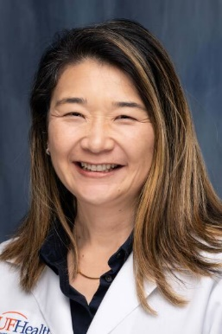

Dr. Renata Shih

Clinical Associate Professor

Department of Cardiology

University of Florida

January 13, 2025

12:30pm-1:30pm

ZOOM presentation

Learning Objectives: **Upon completion of this activity, participants should be able to:**

1. Definition of obesity in children
2. Epidemiology of cardiovascular outcomes in overweight and obese children.
3. Discuss about the most common cardiovascular outcomes of overweight and obese children

For additional information, contact Kimberly Clawson at 352-316-7046 or e-mail [davkim@shands.ufl.edu](mailto:davkim@shands.ufl.edu)

**Disclosure**

Dr. Shih has disclosed that she has no relevant financial relationships. No one else in a position to control content has any financial relationships to disclose.

**CME Advisory Committee Disclosure**   
Conflict of interest information for the CME Advisory Committee members can be found on the following website: <https://cme.ufl.edu/disclosure/>. All relevant financial relationships have been mitigated.

**Target Audience**

Primary Care Pediatricians

**Accreditation**

The University of Florida College of Medicine is accredited by the Accreditation Council for Continuing Medical Education (ACCME) to provide continuing medical education for physicians.

**Credit**

The University of Florida College of Medicine designates this live activity for a maximum of 1 *AMA PRA Category 1 Credit™*. Physicians should claim only the credit commensurate with the extent of their participation in the activity.

Section #